How to do a git config global edit? The global git config is simply a text file, so it can be edited with whatever text editor you choose. Open, edit global git config, save and close, and the changes will take effect the next time you issue a git command. It's that easy.

how to check git configuration

**To see the contents of this folder, use the following command:**

1. Mac: Type ls and hit Return.
2. Windows using Git Bash: Type ls and hit Enter.
3. Windows using Command Prompt: Type dir and hit Enter.

git config –list

git config --list --show-origin

Using the command line we can also remove Git user details and Git remote origin URL with the help of git config --global --unset user.name and git remote remove origin commands respectively.১

Configure Git

Now let Git know who you are. This is important for version control systems, as each Git commit uses this information:

Example

git config --global user.name "rashed"

git config --global user.email "2019.rasu.alam@gmail.com"

Change the user name and e-mail address to your own. You will probably also want to use this when registering to GitHub later on.

**Note:** Use global to set the username and e-mail for **every repository** on your computer.

If you want to set the username/e-mail for just the current repo, you can remove global

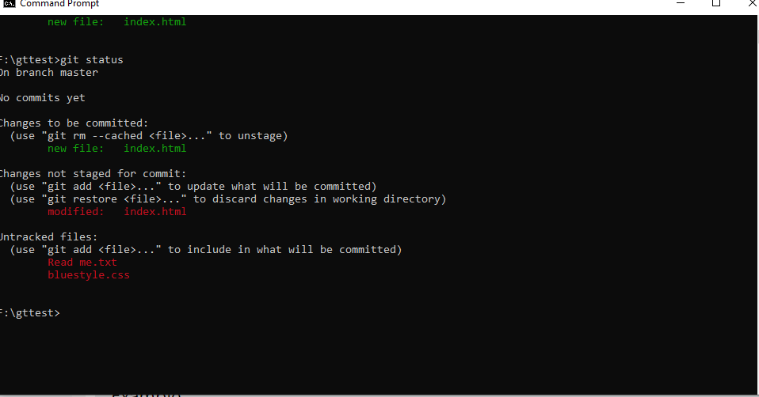

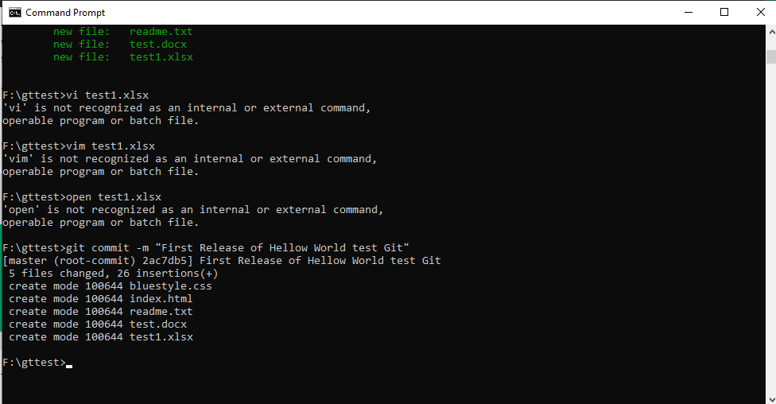

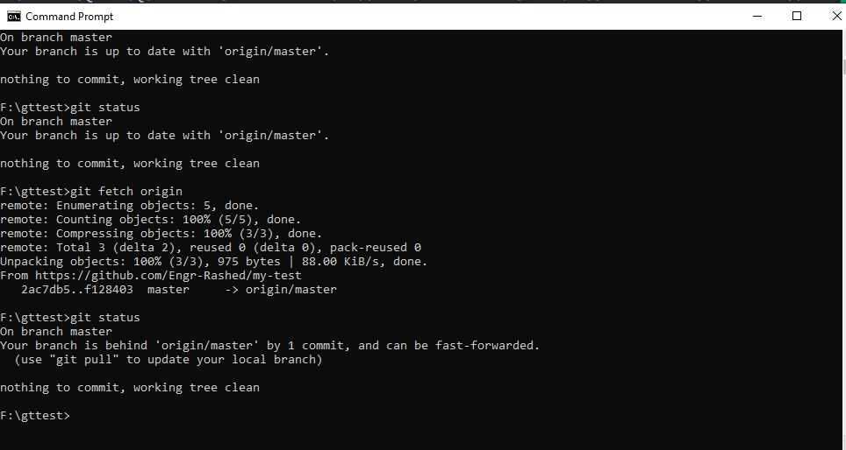

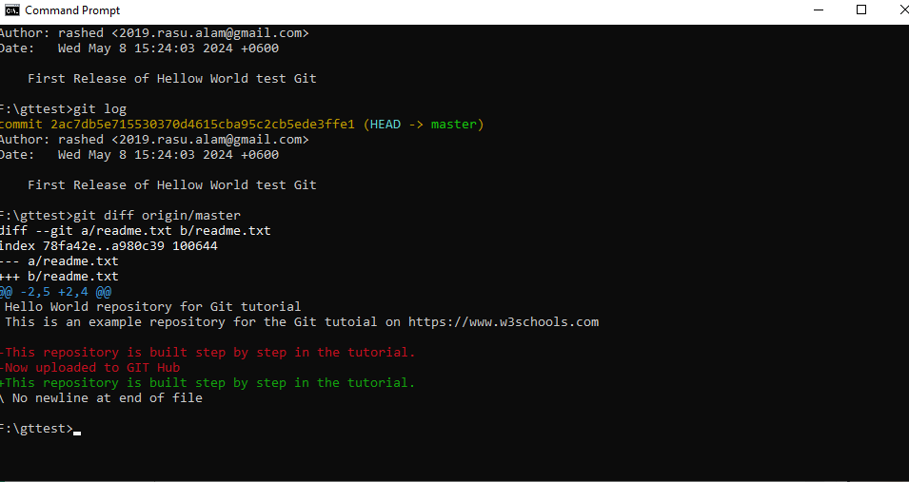

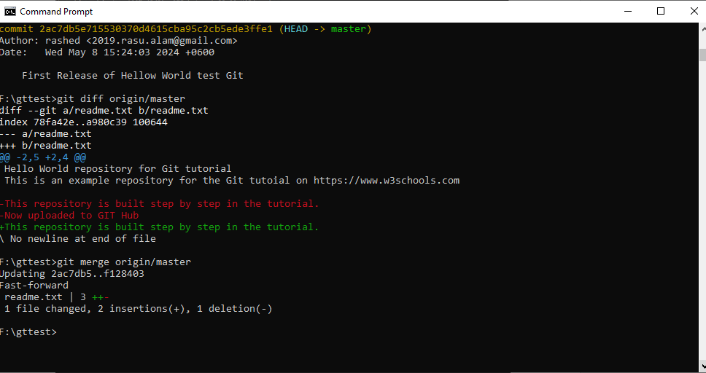

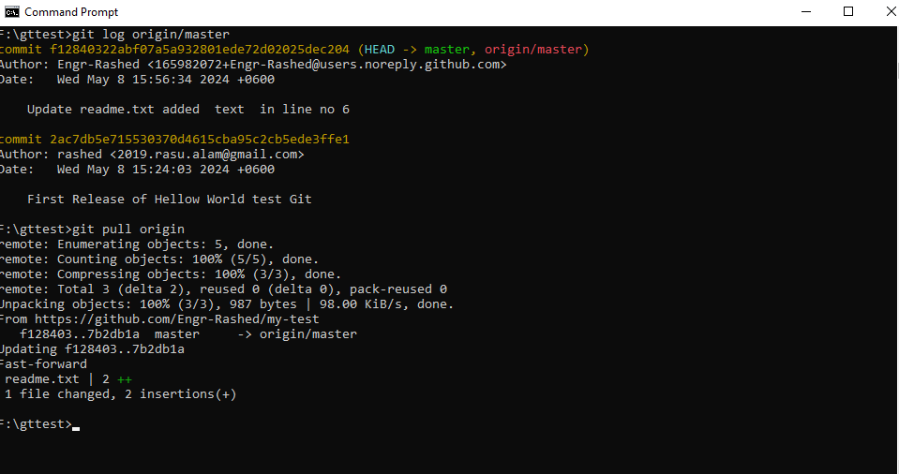

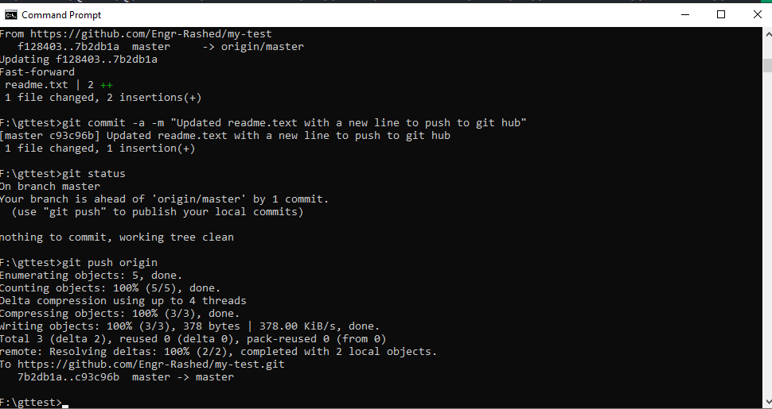

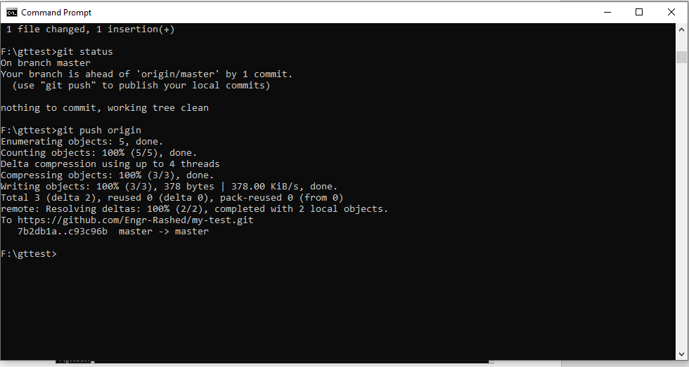

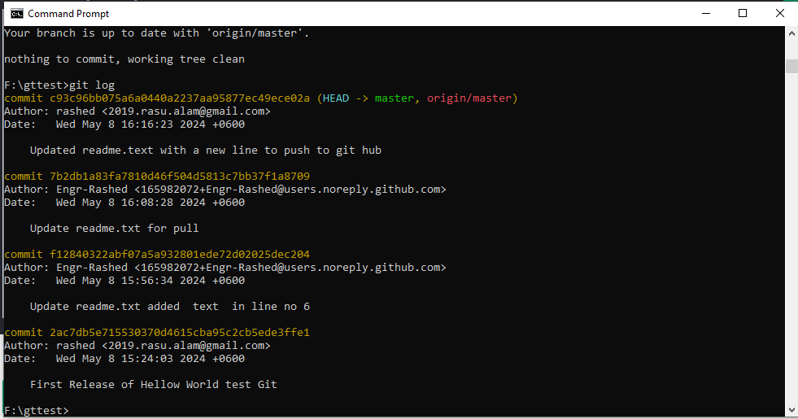

F:\gttest>git commit -m "First Release of Hellow World test Git"

[master (root-commit) 2ac7db5] First Release of Hellow World test Git

5 files changed, 26 insertions(+)

create mode 100644 bluestyle.css

create mode 100644 index.html

create mode 100644 readme.txt

create mode 100644 test.docx

create mode 100644 test1.xlsx

F:\gttest>

On branch master

No commits yet

Changes to be committed:

(use "git rm --cached <file>..." to unstage)

new file: bluestyle.css

new file: index.html

new file: readme.txt

F:\gttest>git rm --cached readme.txt

rm 'readme.txt'

F:\gttest>git status

On branch master

No commits yet

Changes to be committed:

(use "git rm --cached <file>..." to unstage)

new file: bluestyle.css

new file: index.html

Untracked files:

(use "git add <file>..." to include in what will be committed)

readme.txt

F:\gttest>

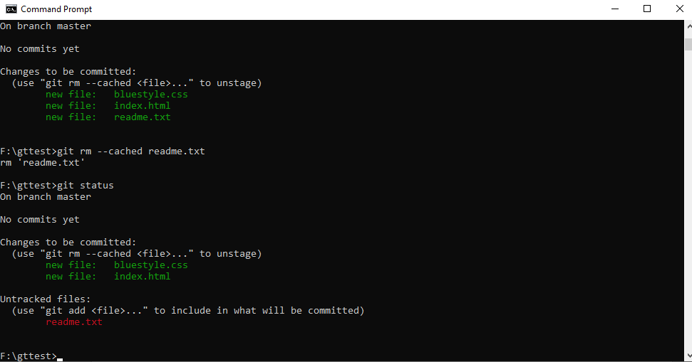

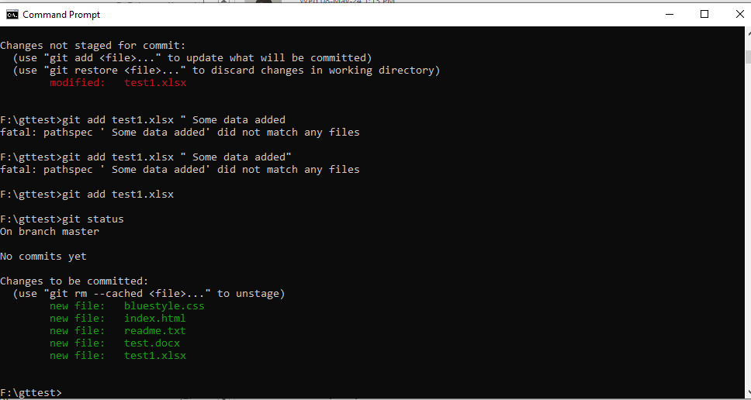

Microsoft Windows [Version 10.0.19045.4291]

(c) Microsoft Corporation. All rights reserved.

C:\Users\rashidul.alam>git-show

'git-show' is not recognized as an internal or external command,

operable program or batch file.

C:\Users\rashidul.alam>cd..

C:\Users>cd..

C:\>f:

F:\>cd gttest

F:\gttest>ls

'ls' is not recognized as an internal or external command,

operable program or batch file.

F:\gttest>git status

On branch master

No commits yet

Untracked files:

(use "git add <file>..." to include in what will be committed)

index.html

nothing added to commit but untracked files present (use "git add" to track)

F:\gttest>git add index.html

F:\gttest>ls

'ls' is not recognized as an internal or external command,

operable program or batch file.

F:\gttest>git ststus

git: 'ststus' is not a git command. See 'git --help'.

The most similar command is

status

F:\gttest>git status

On branch master

No commits yet

Changes to be committed:

(use "git rm --cached <file>..." to unstage)

new file: index.html

F:\gttest>git status

On branch master

No commits yet

Changes to be committed:

(use "git rm --cached <file>..." to unstage)

new file: index.html

Changes not staged for commit:

(use "git add <file>..." to update what will be committed)

(use "git restore <file>..." to discard changes in working directory)

modified: index.html

Untracked files:

(use "git add <file>..." to include in what will be committed)

Read me.txt

bluestyle.css

F:\gttest>git add Readme.txt

fatal: pathspec 'Readme.txt' did not match any files

F:\gttest>git add Read me.txt

fatal: pathspec 'Read' did not match any files

F:\gttest>git add index.html

F:\gttest>git Status

git: 'Status' is not a git command. See 'git --help'.

The most similar command is

status

F:\gttest>git status

On branch master

No commits yet

Changes to be committed:

(use "git rm --cached <file>..." to unstage)

new file: index.html

Untracked files:

(use "git add <file>..." to include in what will be committed)

Read me.txt

bluestyle.css

F:\gttest>>git add read me.txt

'add' is not recognized as an internal or external command,

operable program or batch file.

F:\gttest>git add readme.txt

F:\gttest>git status

On branch master

No commits yet

Changes to be committed:

(use "git rm --cached <file>..." to unstage)

new file: index.html

new file: readme.txt

Untracked files:

(use "git add <file>..." to include in what will be committed)

bluestyle.css

git

F:\gttest>git add bluestyle.css

F:\gttest>git status

On branch master

No commits yet

Changes to be committed:

(use "git rm --cached <file>..." to unstage)

new file: bluestyle.css

new file: index.html

new file: readme.txt

Untracked files:

(use "git add <file>..." to include in what will be committed)

git

F:\gttest>git stutus

git: 'stutus' is not a git command. See 'git --help'.

The most similar command is

status

F:\gttest>git status

On branch master

No commits yet

Changes to be committed:

(use "git rm --cached <file>..." to unstage)

new file: bluestyle.css

new file: index.html

new file: readme.txt

F:\gttest>git rm --cached

fatal: No pathspec was given. Which files should I remove?

F:\gttest>git rm --all

error: unknown option `all'

usage: git rm [-f | --force] [-n] [-r] [--cached] [--ignore-unmatch]

[--quiet] [--pathspec-from-file=<file> [--pathspec-file-nul]]

[--] [<pathspec>...]

-n, --[no-]dry-run dry run

-q, --[no-]quiet do not list removed files

--[no-]cached only remove from the index

-f, --[no-]force override the up-to-date check

-r allow recursive removal

--[no-]ignore-unmatch exit with a zero status even if nothing matched

--[no-]sparse allow updating entries outside of the sparse-checkout cone

--[no-]pathspec-from-file <file>

read pathspec from file

--[no-]pathspec-file-nul

with --pathspec-from-file, pathspec elements are separated with NUL character

F:\gttest>git status

On branch master

No commits yet

Changes to be committed:

(use "git rm --cached <file>..." to unstage)

new file: bluestyle.css

new file: index.html

new file: readme.txt

F:\gttest>git rm --cached readme.txt

rm 'readme.txt'

F:\gttest>git status

On branch master

No commits yet

Changes to be committed:

(use "git rm --cached <file>..." to unstage)

new file: bluestyle.css

new file: index.html

Untracked files:

(use "git add <file>..." to include in what will be committed)

readme.txt

F:\gttest>git add readme.txt

F:\gttest>git status

On branch master

No commits yet

Changes to be committed:

(use "git rm --cached <file>..." to unstage)

new file: bluestyle.css

new file: index.html

new file: readme.txt

F:\gttest>git status

On branch master

No commits yet

Changes to be committed:

(use "git rm --cached <file>..." to unstage)

new file: bluestyle.css

new file: index.html

new file: readme.txt

Untracked files:

(use "git add <file>..." to include in what will be committed)

test.docx

F:\gttest>git status

On branch master

No commits yet

Changes to be committed:

(use "git rm --cached <file>..." to unstage)

new file: bluestyle.css

new file: index.html

new file: readme.txt

Untracked files:

(use "git add <file>..." to include in what will be committed)

test.docx

test1.xlsx

F:\gttest>git add test.docx

F:\gttest>git add test1.xlsx

F:\gttest>git status

On branch master

No commits yet

Changes to be committed:

(use "git rm --cached <file>..." to unstage)

new file: bluestyle.css

new file: index.html

new file: readme.txt

new file: test.docx

new file: test1.xlsx

F:\gttest>git status

On branch master

No commits yet

Changes to be committed:

(use "git rm --cached <file>..." to unstage)

new file: bluestyle.css

new file: index.html

new file: readme.txt

new file: test.docx

new file: test1.xlsx

Changes not staged for commit:

(use "git add <file>..." to update what will be committed)

(use "git restore <file>..." to discard changes in working directory)

modified: test1.xlsx

F:\gttest>git add test1.xlsx " Some data added

fatal: pathspec ' Some data added' did not match any files

F:\gttest>git add test1.xlsx " Some data added"

fatal: pathspec ' Some data added' did not match any files

F:\gttest>git add test1.xlsx

F:\gttest>git status

On branch master

No commits yet

Changes to be committed:

(use "git rm --cached <file>..." to unstage)

new file: bluestyle.css

new file: index.html

new file: readme.txt

new file: test.docx

new file: test1.xlsx

F:\gttest>